[Egyptian Informatics Journal 21 (2020) 51–66](https://doi.org/10.1016/j.eij.2019.10.005)

Contents lists available at [ScienceDirect](http://www.sciencedirect.com/science/journal/11108665)

Egyptian Informatics Journal

journal homepage: [www.sciencedirect.com](http://www.sciencedirect.com/)

[](http://crossmark.crossref.org/dialog/?doi=10.1016/j.eij.2019.10.005&domain=pdf)A robust clustering algorithm using spatial fuzzy C-means for brain MR images

Madallah Alruwaili ⇑, Muhammad Hameed Siddiqi, Muhammad Arshad Javed

*College of Computer and Information Sciences, Jouf University, Sakaka, Saudi Arabia*

a r t i c l e i n f o

*Article history:*

Received 29 July 2019

Revised 19 September 2019

Accepted 21 October 2019

Available online 18 November 2019

*Keywords:*

Clustering algorithm MRI

Fuzzy C-means

a b s t r a c t

Magnetic Resonance Imaging (MRI) is a medical imaging modality that is commonly employed for the analysis of different diseases. However, these images come with several problems such as noise and other imaging artifacts added during acquisition process. The researchers have actual challenges for segmenta- tion under the consideration of these effects. In medical images, a well-known clustering approach like Fuzzy C-Means widely used for segmentation. The performance of FCM algorithm is fast in noise-free images; however, this method did not consider the spatial context of the image due to which its perfor- mance suffers when images corrupted with noise and other imaging relics. In this paper, a weighted spa- tial Fuzzy C-Means (wsFCM) segmentation method is proposed that considered the spatial information of image. Moreover, a spatial function is also developed that integrate a membership function. In order assess this function, a neighborhood window is established around a pixel and more weights have been assigned to those pixels which have greater correlation with central pixel in local neighborhood. By inte- gration of this spatial function in membership function, the modified membership function strengthens the original membership function in handling the noise and intensity inhomogeneity, which has the abil- ity to preserves and maintains structural information like edges. A comprehensive set of experimentation is performed on publicly accessible simulated and real standard brain MRI datasets. The performance of the proposed method has been compared with existing state-of-the-art methods. The results show that the performance of the proposed method is better and robust in handling noise and intensity inhomo- geneity than of the existing works.

© 2019 Production and hosting by Elsevier B.V. on behalf of Faculty of Computers and Information, Cairo

University. This is an open access article under the CC BY-NC-ND license ([http://creativecommons.org/](http://creativecommons.org/licenses/by-nc-nd/4.0/)

[licenses/by-nc-nd/4.0/](http://creativecommons.org/licenses/by-nc-nd/4.0/)).

1. Introduction

Medical imaging is positioning itself towards automation and intelligence in the second decade of 21*st* century. Magnetic reso- nance imaging (MRI) is a noninvasive medical imaging method for producing anatomical structures of the human body [1]. This

is one of the common and widely used imaging techniques in med- ical imaging due to its excellent capability for soft tissue imaging. This technique has gained appreciable penetration in medical

* Corresponding author.

*E-mail addresses:* [madallah@ju.edu.sa](mailto:madallah@ju.edu.sa) (M. Alruwaili), [mhsiddiqi@ju.edu.sa](mailto:mhsiddiqi@ju.edu.sa) (M.H. Siddiqi), [arsh_qau@ju.edu.sa](mailto:arsh_qau@ju.edu.sa) (M.A. Javed).

Peer review under responsibility of Faculty of Computers and Information, Cairo University.

**Production and hosting by Elsevier**

imaging during last few years due to its safety, reliability and effi- ciency features. MRI is most often used for the diagnosis and detec- tion of tumors, lesions, to observe tissues growth, treatment planning and other abnormalities in brain soft tissues. The MRI method creates scans from measured signals that come directly from the object without needs to inject contrast agents. There is no problem regarding the radiation as it works in the radio fre- quency range. Lastly, it creates different images concentrating on one specific property of a same object by changing some intrinsic parameters of the system. This technique has a problem that is related to application of magnetic fields in the encoding process. These images are subject to different noises while taking the data, which affects quality and diagnostics of the image. Investigating MRI images help the doctors to take right judgments. Nevertheless, MRI noises reduce the quality of the image that badly disturbs the work of analyzing and processing image, for instance registration, classification, segmentation, and visualization. To achieve consis- tent examination results, eliminating the noise from the MRI image is necessary before conducting image processing [2].

<https://doi.org/10.1016/j.eij.2019.10.005>

1110-8665/© 2019 Production and hosting by Elsevier B.V. on behalf of Faculty of Computers and Information, Cairo University. This is an open access article under the CC BY-NC-ND license (<http://creativecommons.org/licenses/by-nc-nd/4.0/>).

The image segmentation in a divider contains diverse sections that transmit alike pixels inside same sections and unlike from another sections pixels. Image segmentation plays a vital role in medical imaging. In MRI images examination, the segmentation is widely used to calculate and imagine the functional construc- tions of brain, for examining variations in brain, for defining com- pulsive sections, and for medical preparation and image-guided involvements [3]. MRI scanners produce many images for patient area of interest and thus a doctor (radiologist) has to assess quali- tatively a huge amount of MRI images of a distinct patient pro- duced by MRI scanners. Despite their best expertise and effort, human judgment and sight can be often deceiving. The incorrect judgment might cause harm consequences [4]. Automated support in disease diagnosis and detection process can not only improve the judgment quality but also ease the tedious process of diagnosis. This is particularly true with MRI based diagnosis of brain diseases because of unique intricate structure of brain as well as the signif- icance of extremely precise detection. In such a scenario, automatic intelligent segmentation technique of brain classes tissue is needed to finish the segmentation of MR images. However, this brain tissue segmentation is a very concerning task because of the morphology of brain tissue structure joint with noise, incom- plete capacity consequence and image preference field existing the separation of their association with robust pixel uncertainty and indecision [5,6]. This level of complexity clearly points towards a need for such computer method, which could reproduce accurate segmentation under these challenges and provide support to radiologists or experts or medical community in decision mak- ing. There are 86 billion (approx) nerve cells or neurons and bil- lions of nerve fibers or axons in brain, which are known as gray matters (GW) and white matters (WM) respectively. These neu- rons are connected by trillions of connections, or synapses [7]. The brain also carries in it an amount of cerebrospinal fluid (CSF) which has some concentrated amount of energy supplement of glucose, salts, and biological ingredients of enzymes, and white blood cells. In numerous clinical applications, the correct segmen- tation of brain MR images in certain brain tissue classes is a signif- icant concern, which might be varied such as WM, GM and CSF is a crucial job [8]. If this information is in hand, then the quick analysis might be done. For disease identification, the correct assessment may be very crucial. In neurological research, the automatic seg- mentation of brain MR images plays a vital role [5,8]. In literature, some computer based image segmentation approaches have been developed for the analysis of brain functional arrangements. Among them, thresholding-based, region-based, Markov Random Field and clustering-based methods are the most frequently used segmentation techniques.

Thresholding method [3] uses the intensity histograms and tries to determine intensity values that is called threshold. Threshold partitions the data into target classes and all the pixels are grouped into one class based on thresholds into one class due to which the segmentation is completed. The intensity distribution in medical images, mainly in MRI is mostly complicated and hence, threshold- ing based methods cannot determine the optimal thresholding value. Tough, computationally, thresholding techniques are well- organized and simple; however, they did not take into account the spatial context of the image and pixel location information is ignored [9]. Region-growing methods [3] extract a connected region consisting of groups of pixels having similar intensities of the image [10]. These methods need starting point commonly known as seed point which is a pixel in the image that fits to the object of attention. The kernel opinion is nominated manually by the user or seed finding algorithm is used which initialize the method automatically. All the adjacent pixels and the associated pixels are added to the growing region due to its examination. Main drawback of region-growing method is the careful initializa-

tion of kernel point and segmentation results might be totally dif- ferent if the kernel point is selected wrong or different. Another disadvantage of region-growing methods is noise sensitivity. In segmented images, regions are disconnected or there can be holes in the regions in the presence of noise and thus, less preferred for medical image segmentation [3]. Markov Random Field models are basically graphical models and representation of these models is similar to Bayesian Network. Segmentation is performed on the basis of development of models of prior knowledge about the fea- tures of image. These image features are edges, labels of regions, contrast and textures etc. The computational cost is very high and requires some extra time to segment an image and that is one of major concerns of this technique [11].

Clustering segmentation approaches [12] are the methods which divide the image into classes of such image pixels which have the similar intensity characteristics without utilizing the training images. Actually these methods utilize available data of image to train themselves. In clustering methods, the training and segmentation happens in parallel. It is an iterative procedure which is performed into two phases: (i) in first step, data is clus- tered and (ii) in the second step, it estimates the characteristics of each tissue group. The clustering methods are mainly catego- rized in supervised and unsupervised clustering. Supervised clus- tering techniques need the clusters number in advance from user, whereas in unsupervised clustering, the cluster information is decided by the clustering system itself. Clustering methods are simple and works better on homogeneous and overlapped regions of the images however, their performance suffers when applied on inhomogeneous regions and also these methods are sensitive to noise. K-means and Fuzzy C-Means are unsupervised clustering techniques used in image processing and medical image segmenta- tion purpose.

K-means is very simple and restrict one image pixel to be only in one group whereas Fuzzy C-Means assign the possibility to each pixel in an image to be in two or more clusters by assigning the membership degrees. The membership degree determines the true position or true class of any pixel [3]. Although the significance of fuzzy c-means method is very satisfactory and successfully applied in real applications, it has some disadvantages as it does not con- template any spatial context of image and is consequently very subtle to noise and other imaging relic like intensity inhomogene- ity. It may also result in local optimum solution caused by poor ini- tialization [9]. In the past, many modifications of fuzzy c-means algorithm have been done in order for making the algorithm fur- ther robust to noise and imaging artifacts for image segmentation. Pham et al. [13] introduced the modified version of FCM as robust FCM (RFCM) by integrating spatial penalty term in the objective function. However, the new objective function suffers

from complicated variations in the membership function [14]. A brain MRI segmentation approach has been proposed by Chuang et al. [15] that is named as spatial FCM (sFCM), which adjust the membership function of standard FCM method by incorporating the spatial information. This approach is less subtle to noise and in some extent, this method provides better performance. How- ever, this method still has a problem when the outliers of the image is ruined with seriously noise then this method does not show better performance. Furthermore, this method contains those points in the clusters that are not closer to center of the clus- ters. Cai et al. [16] developed an approach for brain MR images seg- mentation using spatial information named as fast generalized Fuzzy C-Means (FGFCM). By using original image along with spa- tial coordinates and the values of gray level of local neighborhood window, a nonlinearly-weighted sub image is produced. By utiliz- ing nonlinearly-weighted sub image, grouping is applied on the histogram of gray levels for the sub images. The method performs fast; however, still has a problem when the image is ruined with

seriously noise then its performance degrade. Furthermore, directly this algorithm might not be employed on the original image because for noise and robustness, it required suspicious fac- tors collection in order to preserve the features that makes the method complicated [17]. Yu et al. [18] developed a segmentation technique for MRI image. In this approach, fuzzy partition entropy is maximized with 2D histogram. Though the technique produces some improved segmentation results but major drawback of this method is its large time complexity and spends long time in find- ing the optimal parameters. The authors of [19] proposed a modi- fied version of standard FCM algorithm by modifying the membership function to segment the MRI images. The significance of the method suffers as the level of noise enlarges and reproduces blur images. Caldairou et al. [20] proposed an MRI segmentation non-local FCM (NL/FCM) method by updating the main function of the FCM technique. In order to make the algorithm more robust against noise and intensity inhomogeneity, non-local regulariza- tion term is integrated with non-local data term and incorporated in the objective function. Zhao et al. [21] developed a modified ver- sion of regular FCM for segmentation by adding non-local spatial information in FCM. The performance of this method is better and suppresses more noise effects and deal with inhomogeneity but the performance declines at high noise effects. Ji et al. [22] pro- posed a brain MRI image segmentation approach by using spatial information which integrates the weighted patch of image with the standard FCM algorithm. The weights have been calculated based on eight neighbors around the central pixel in the squared window. The weights incorporated in the FCM algorithm have been calculated by patch instead of individual pixels in the patch. Though the method effectively reduces MRI noise interference, however, it becomes very complicated, and fails to segment brain tissues accurately [23]. Wang et al. [19] developed a technique for brain MRI segmentation. They modified the main function of regular FCM approached in the presence of noise, by integrating the information-theoretic structure into the normal FCM in order to make the method more robust. The proposed method is much better than of the regular FCM with capability of catering noise problem. However, in the presence of high level of noise, the signif- icance of this method gradually decreased. Alipour et al. [24] developed a segmentation method by merging spatially inhibited kernel-based Fuzzy C-Means method (SKFCM) and a Fast-Two-

Cycle (FTC) method. SKFCM creates a rough segmentation to

method, a new gray-difference coefficient is employed to calculate the consequence of neighboring pixels for enhancing the perfor- mance against noise.

Most of the methods that have been reviewed above suffer severely from noise and other noise multiplicative parameter intensity inhomogeneity in the MRI. The intensity inhomogeneity which is also known as intensity non-uniformity (INU) is the non-uniformities of intensities over the same class of tissues or structures. This imaging artifact significantly decreases the perfor- mance of any type of image processing algorithm that uses inten- sities as a feature and also reproduces poor segmentation.

In order to face above challenges and issues, this paper describes a clustering based method weighted spatial fuzzy c- means (wsFCM) by utilizing spatial context of images.

We have already described certain literature review about this field. The rest of the paper is prepared as follows: Section 2 pre- sents an overview of standard FCM algorithm. Section 3 describes the detail of proposed methodology. In Section 4, the evaluation and validation strategy of the proposed method have been repre- sented. The results and discussions have been described in Sec- tion 5. The paper will finally be concluded after some discussions in Section 6.

1. Standard Fuzzy C-Means (FCM) method

The standard FCM was developed by [9–14] that was modified by [27] in 1981. The FCM algorithm is a clustering technique where every data point fits to in excess of one cluster. The algorithm starts with an initial guess of randomly picked centers of every cluster. The FCM algorithm attempts to associate each of the data point to one of the clusters by assigning a degree of membership based on likelihood. In clusters, a probability distribution function is utilized to assign the membership degree for each data point. FCM is an iterative method which aims at minimization of an objective function. When each data point becomes closer to their respective clusters centers, the objective function is minimized and algorithm terminates. A higher degree value is allotted to those items which have short distance from cluster center and lower to those which have large distance from that of cluster cen- ter. The clusters centers are revised after each of iteration. The objective function of FCM algorithm is given as:

*N C*

choose the primary contour spontaneously and the partition

*JFCM* = XX*Umxi* — *v*2

(1)

matrix formed by this algorithm is presented to FTC for segmenta- tion. There is no mechanism to suppress the noise effect. Ali et al.

[25] proposed a segmentation method Wavelet Morphological Fusion Fuzzy C-Means (WMMFCM) for brain MRI image. In this approach, first wavelet transform is applied on input image till 3rd levels and obtained the wavelet coefficients at each level. Later these coefficients are fused with original image through using the morphological pyramids to increase the sharpness and decrease the effect of noise. After this the FCM algorithm is employed to the fused images for segmentation. The performance of the tech- nique is better than some previous methods but the resulting images still contains noise. Adhikari et al. [9] proposed the modi-

*ij j*

*i*=1 *j*=1

where *N* represents the total items of the data, *C* indicates the clus- ters number, *vj* represents the center of the cluster *j*.  ·  is a norm metric which measures the intimacy of data item *xi* to center of the

cluster *jth*, *m*(> 1) is the fuzziness co-efficient which calculates the acceptance of the compulsory grouping and finds how much the clusters overlays thru one another, and *U* is the membership matrix which contains the membership degrees. Suppose, we have a data point *xi*, then the cluster membership degree j is measured as below:

fied version of FCM in order to generate the conditional spatial FCM (csFCM). In this method, membership function of standard FCM is modified to incorporate conditional factors describing the pixel involvement level in order to built clusters and spatial infor- mation as well. Regardless of providing better performance, in some cases, this approach misplaces valuable information about tissues. Moreover, the authors also described the limitations that the significance of the their proposed approach decreased in the presence of high level of noise; while the intensity inhomogeneity enlarged. Deng et al. [26] developed the updated version of stan- dard FCM approach by modifying the objective function. In this

*Uij* = 1

*xi* —*vj m*—1

X

*c* 2

*xi* —*vk*

*k*=1

and the cluster center *vj* is calculated as follows:

*N*

X*U* .*xi*

*m ij*

*vj* = *i*=1

*N*

X

*m ij*

*U*

*i*=1

(2)

# (3)

It is worth to note that as the FCM algorithm starts, the membership degree *m* for data point *i* against cluster *j* is initialized with a casual number between 0 and 1, as below:

X*Uij* = 1

*C*

*j*

1. Proposed methodology

The overall framework of the proposed methodology is repre- sented in Fig. 1. The detail of the proposed methodology is given below in subsections.

* 1. *Preprocessing*

There are some factors such as noise and the overlapping of tis- sues intensities make the segmentation a challenging task in brain MR images.

The MR images may possess the noise, which affects the perfor- mance and quality of segmentation and also affects the diagnosis of diseases. Therefore, a preprocessing step is important for brain

MR images before performing the segmentation. So, for noise

geneity. In order to face and handle these issues, a clustering based method weighted spatial fuzzy c-means (wsFCM) by considering the spatial context of images has been developed for the segmen- tation of brain MRI images. A spatial function is proposed and incorporated in the membership function of regular fuzzy c- means algorithm. The spatial function fully utilizes the spatial characteristics of the image and assigns weights to the neighboring pixels according to their correlation with central pixel in the neigh- borhood window. More weights are assigned to those pixels which have low intensity distance and high weights to those which have larger distance from the central pixel in the local neighborhood window. The incorporation of spatial function into membership function expands the heftiness of the approach to noise and inten- sity inhomogeneity thus providing excellent outcomes of segmen- tation. The spatial function strengthens the membership function which is helpful in preserving the edges of the regions in the image.

In the proposed method, the segmentation process as clustering problem has been formulated. As clustering is an optimization problem, which is usually described by some objective function and constraint. In the developed approach, the following objective function has been proposed:

*n c*

removing, recently published method that was based on hybrid genetic filter has been utilized [28].

On the other hand, the isolation of brain and non-brain tissues is considered as an important step for the accurate segmentation. Because, the intensities of brain tissues to illustrate gray matter (GM), white Matter (WM), and cerebrospinal fluid (CSF) may over- lap with non-brain tissues like muscles, fats, and bones that may complicate the segmentation process. Therefore, after removing the noise effects, the paper proposed the usage of Brain Extraction

*Jobj* = XX(l, )*mxi* — *c*2, 1 < *m* < ∞ (4)

*i*=1 *j*=1

*ij j*

With constraints P*c* l, (*i*, *j*) = 1 and c – /.

*k*=1

*k*

where *xi* is data point, *cj* is cluster center in *jth* cluster, *m* is fuzzi- ness coefficient that controls the overlapping of clusters with one another, and l'*ij*, is the modified membership function, which is

given as below:

l*psq*

Tool [29] for the separation of brain parts and non-brain parts.

* 1. *Weighted Spatial Fuzzy C-Means (wsFCM)*

l'*ij* = *ij ij*

*p q*

*c*

Xl *s*

*kj kj*

*k*=1

(5)

The fascinating characteristic of the image is to exceedingly cor- relate the neighboring pixels with each other. However, this important context does not utilize in the regular FCM approach because it lack of robustness against noise and intensity inhomo-

where *p* and *q* are two factors that control the comparative rank of all functions, and *sij* represents the three-dimensional function that is coupled with the membership function. The three-dimensional function *sij* is given as:

*sij* = X

*k*∈*NBH*(*xi*)

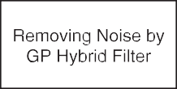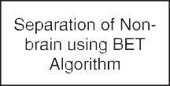

l*jk* (6)

Where NBH indicates a squared neighborhood window in three- dimensional domain with center pixel *xi*. The three-dimensional context of the image is employed for the development of this three-dimensional function. In this context, the neighboring pixels possess maximum similarity with the center pixel. Due to this cor- relation, it might be possible that all the neighboring pixels be in the same cluster. In order to utilize the above spatial context, a 5 × 5 squared window around a pixel with all its possible directions

has been used as shown in Fig. 2 Let *Ik*, (*k* = 1, 2, 3, 4) act for the set

of directs allied with the *kth* center at (0, 0) in spatial neighborhood. These coordinates are shown in Fig. 2, which is given below:

*I*1 = {(0, —2), (0, —1), (0, 0), (0, +1), (0, +2)}

*I*2 = {(—2, 0), (—1, 0), (0, 0), (+1, 0), (+2, 0)}

*I*3 = {(—2, —2), (—1, —1), (0, 0), (+1, +1), (+2, +2)}

*I*4 = {(—2, +2), (—1, +1), (0, 0), (+1, —1), (+2, —2)}

*I*(0) = *Ik* \ (0, 0)6*k* from 1 to 4 (shown in Fig. 2.

*k*

In 5 × 5 window with center (*i*, *j*), we defined *dk*

(*i*,*j*)

as the sum-

Fig. 1. Architectural diagram for the Proposed Methodology.

mation of the whole changes between *y*( *i* + *s*, *j* + *t*) and *y*( *i*, *j*) with

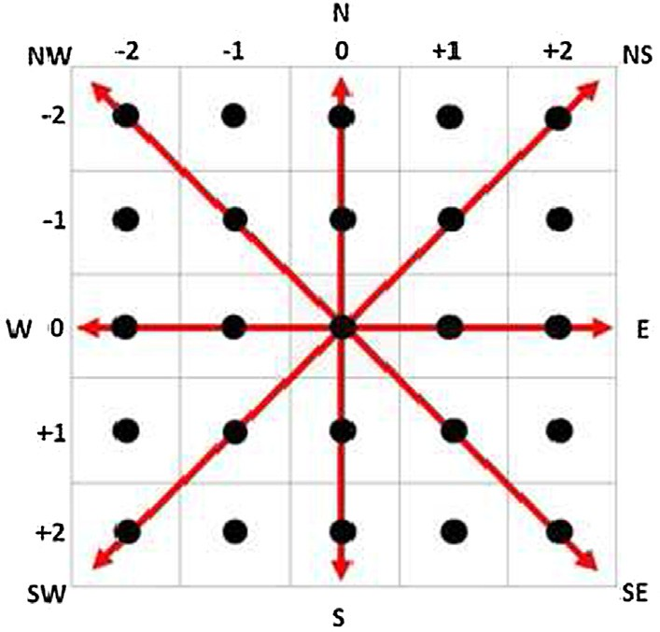function *sij* stances for the possibility that a pixel *xi* fits to *ith* cluster. The three-dimension function of a pixel for a cluster is in height if majority of the neighbors fits to the similar cluster. In a same area, the three-dimension function strengthens the association function and clustering outcome ruins unaffected. But, for noisy or irregular pixels, this function decreases the weighting of noisy or irregular pixels by labeling its neighbors. Consequently, the irregular or mis- classified pixels from noisy zones can be classified correctly.

In order to calculate the clusters centers based on modified membership function, this paper used the following function:

*n*

Xl *xi*

,*m ij*

*cj* = *i*=1

*n*

Xl

,*m ij*

# (9)

Fig. 2. 5 × 5 squared neighborhood window.

*i*=1

(*s*, *t*)∈ *I*(0). If the distance amongst the two pixels in the three- dimension is minor, then their gray values must be closer. There- fore, there might be a chance that both pixels will be the part of the same cluster. We assigned larger weights to those pixels which have least spatial distance along with each direction i.e., *w* = 2 and small weights to remaining directional pixels which have large spatial distances i.e., *w* = 1 before calculating sum. The sum of spa- tial distances is calculated as:

*k*

*dk* = X *ws t* *yi s j t* — *yi j* , 1 6 *k* 6 4*and*(s, t) ∈ X3 (7)

The weighted spatial fuzzy c-means (wsFCM) is described in the Fig. 3. It is obvious from Fig. 3, that the association values are ran- domly primed; so, that the restraint on the summation of associa- tion for every point must be fulfilled. In distinction, additional principles for initialization also occur. For example, the association of a point in the entire classes might be reset along with equal val- ues. But during execution, it followed the accidental initialization principles to create the method reliable along with the regular FCM.

*i*,*j* , + , + ,

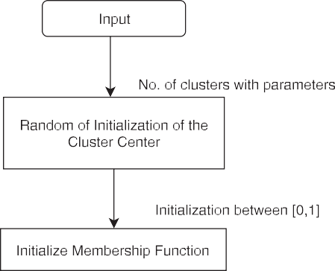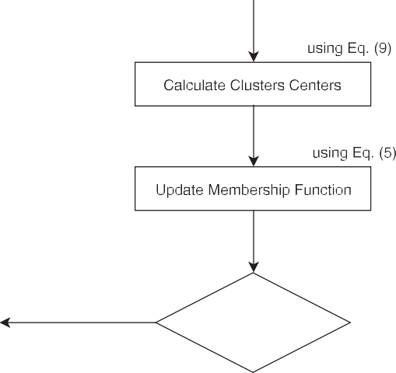

*s*,*t*∈*I*0

*k*

X3 = {(*s*, *t*) : —2 6 *s*, *t* 6 +2}

*k i*,*j*

*d*

is useful for preserving the edges pixels. This paper calculated

the minimum average spatial value along with each direction as given below:

*dmin* = *min*n*dk where* 1 6 *k* 6 4o (8)

*i*,*j*

where *dmin* is the minimum average spatial value among all direc- tions like vertical, horizontal and diagonals. In order to differentiate edges, noisy or irregular and smooth pixels, this paper proposed the usage of a method proposed by Dong [30] with minor changes. The referred method calculated the threshold value by first fixing it and then varying during iterations. The proposed method calculated the threshold value *Tw* by taking the average of absolute differences along each direction and then compared it with the minimum aver- age value *dmin*. So, for that the following cases has been considered:

Case 1: *dmin* < *Tw*.

This means that the current pixel is a normal pixel, *dmin* is small, because of the four small directional indices.

Case 2: *dmin* < *Tw*.

This implies that, when the present pixel is an edge pixel, *dmin*

will be small, because at least one of the direction indices is small.

Case 3: *dmin* > *Tw*.

This implies that, when the present pixel is an irregular pixel,

*dmin* will be large, because of the four large directional indices.

In this way, this paper differentiates the smooth, edges and irregular pixels. The edges and smooth pixels are left untreated, preserved and only irregular pixels have been corrected. In order to remove irregularity of the irregular image pixels, the central pixel is replaced with the average intensity values of those pixels which have minimum spatial distance in each direction.

The three-dimension function is integrated in the association function. Similar like association function, the three-dimension

Fig. 3. Descriptive form of the proposed weighted spatial fuzzy c-means (wsFCM) algorithm.

1. Validation of proposed methodology
   1. *Used datasets*

We performed a set of experiments on publicly available stan- dard datasets such as simulated and real datasets in order to assess

X*cardinality*(*Ai*∩*Ci* )

*SA* = *i*=1

*P*

*P*

## X*cardinality*(*Ci*)

*i*=1

# (11)

the significance of the proposed segmentation methodology. Each dataset is described as below in subsections.

* + 1. *Simulated dataset*

This dataset contains 181 typical images of brain MRI. The normal volume size for such images are 181 × 217 × 181 pixels axial sight learnt at strength non-uniformity (‘‘RF”) 20% and 40%, fluctuating different level of noise as 1%–18%, reduction

where, *Ai* , *Ci* represent the set of pixels in *ith* cluster formed by the algorithm and reference image respectively, and P denotes the total pixels in a cluster.

* + 1. *Structured Similarity Index Measure (SSIM)*

Structured Similarity Index Measure (SSIM) [34] assess the sim- ilar details between reference image and segmented images [35]. SSIM can be calculated using equation:

period (TR) 18 ms, reverberation period (TE) 10 ms and piece thickness 1 mm. The modalities employed in order to create such

## *SSIM*

(2l*x* l*y* + *C*1)(2r*xy* + *C*2)

(*x*, *y*) = (l2 + l2 + *C*1)(r2 + r2 + *C*2) (12)

replicated database of MR images are T1-weighted and T2- weighted. Functional replicas for the ground truth are presented in this dataset that is also utilized for the purpose of quantita- tive evaluation and validation. In this dataset, most of the images have a special file format named NetCDF (MINC), which is commonly used in medical domain, and window cannot read them directly. Therefore, an image-editing tool such as Medical Image Processing Analysis and Visualization (MIPAV) version

7.3.0 [31] was used in order to convert NetCDF (MINC) images to JPEG.

* + 1. *Real dataset*

This dataset has been downloaded from Internet Brain Seg-

*x y x y*

where l*x* , l*y* denote the mean and standard deviations of the refer- enced and restored images, while r*xy* represents their cross correla- tion in terms of mean and standard deviations of both images. *C*1, *C*2 represent constants used to control the instability when denominator approaches near to zero.

* + 1. *Similarity Index (P)*

Similarity index (*p*) [36] is employed to measure the similarity between two segmentation. If *Ak* and *Bk* represents the pixels in cluster *Ci* segmented by the method and reference image, then similarity index can be defined as:

mentation Repository (IBSR) and its manual was delivered by the Center for Morphometric Analysis at Massachusetts General Hospital [32]. This images in this dataset are ‘‘IBSR-V2.0-nifti-st

*c*

## *p*

= 1 X

*c k*=1

2 *A* ∩*Bk*

# (13)

*k*

|*Ak*| + |*Bk*|

ripped” which were taken from a 35 years old female. This data- set contains of 256 axial sight T1-weighted positionally stabi- lized revolution, which have a common dimensions 256 × 128 with piece thickness of 1.5 mm. Manually the anatomical models such as ground truths are utilized for the results validation of the proposed approach.

* 1. *Performance parameters*

The *p* is ranged in [0, 1], and the best value is 1, which shows the

better performance of the algorithm.

* + 1. *Partition Coefficient (PC)*

Partition coefficient [36] is widely used to measure the fuzzy partition. The ideal value for *Pc* is 1 but the values closer to 1 also indicate the better performance of the method. The *Pc* is defined as:

*c N*

In order to assess the quantitative performance of the proposed method, Dice Similarity Coefficient (DSC), Segmentation Accuracy (SA) and Structured Similarity Index Metric (SSIM) metrics has been used. The DSC, SA and SSIM values closer to 1 indicate better

performance of the segmentation methods. Detail of each metric is

XXl,2

*Pc* = *i*=1 *j*=1

*ij*

## *N*

* + 1. *Partition Entropy (PE)*

# (14)

given below.

* + 1. *Dice Similarity Coefficient (DSC)*

Dice Coefficient [33] measures the spatial overlap of two sets. In the segmentation frameworks, this method is used to assess the performance of the segmentation method. In this method, the one set is the segmented image from the method and the other set is the manual segmentation of the same image by the expert. The Dice Similarity Coefficient (DSC) is defined as:

Partition entropy [36] measures the entropy of the fuzzy parti- tion. *Pc* values are ranged in the interval 0 and 1. The optimal value

## *DSC*

2 *A*∩*R*

(*A*,*R*) = |*A*| + |*R*| (

# 10)

where *A* indicates the pixels of segmented image extracted by the system and *R* is the area of brain part image marked by the expert.

* + 1. *Segmentation Accuracy (SA)*

The segmentation accuracy (SA) [9] is the ratio of summations of perfectly categorized pixels and total pixels of the clustered image. The SA is defined as follows:

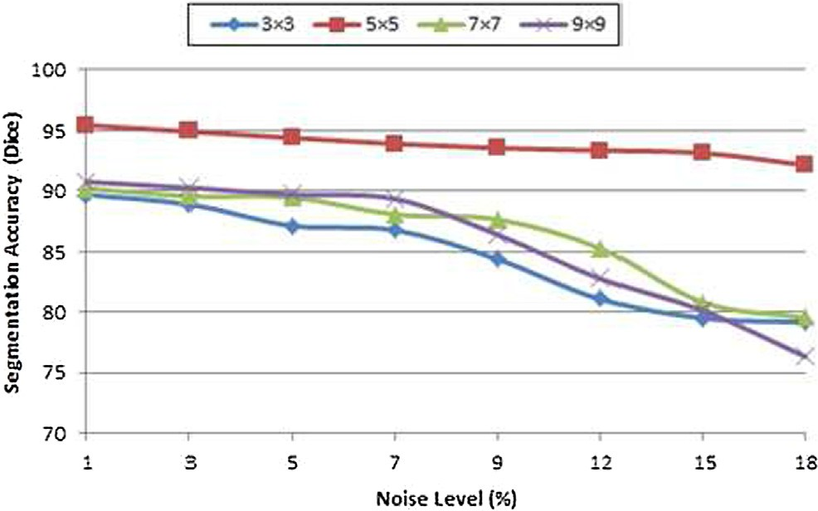Fig. 4. Effect of different neighborhood window sizes on the performance.

of *Pc* is 0 but the values nearer to 0 also indicate the better performance.

of the image, a 5 × 5 square neighborhood window has been used in the proposed method to assign the directional weights to each pixel in the window. Neighborhood plays an important role to

*c N*

XXl,2

*Pc* = *i*=1 *j*=1

*ij*

## *N*

* 1. *Parameters setting*

# (15)

select or find out the optimal value in the case of noisy or irregular or for the central pixel. The proposed algorithm is also tested by increasing or decreasing the neighborhood window size, but the algorithm generates better results in case of 5 × 5 window size. Actually, in the case of 3 × 3, all neighboring pixels have same dis- tance from center. In order to cater more neighborhood informa- tion especially when the neighborhood of center pixel lies on

The parameters *p*, *q* of membership function and window size plays a significant role and has effect on the final membership val- ues. The proposed method has been tested with different combina- tion of values of *p* and *q* but the significant results achieved when *p* = 2 and *q* = 2 has been used. By considering the spatial context

edges or boundaries of clusters, it is better to consider next neigh- borhood pixel. Thus in the proposed method 5 × 5 window has been incorporated. Experimental testing has also been performed to validate it and it works well as comparative to 3 × 3. The pro- posed algorithm has also been tested with 7 × 7 and 9 × 9, but it

Table 1

Accuracy of the proposed segmentation methodology in terms of Dice Similarity Score on simulated T1-weighted dataset images with intensity inhomogeneity (IIH) 20%.

|  |  |  |  |  |  |  |  |  |  |  |  |
| --- | --- | --- | --- | --- | --- | --- | --- | --- | --- | --- | --- |
| Slice | Tissues |  |  |  |  | Noise Level |  | | | | |
|  |  | 0% | 1% | 3% | 5% | 7% | 9% | 12% | 15% | 18% |  |
| #62 | GM | 0.9634 | 0.9606 | 0.9543 | 0.9503 | 0.9477 | 0.9368 | 0.9313 | 0.9241 | 0.9172 |  |
|  | WM | 0.9677 | 0.9654 | 0.9629 | 0.9601 | 0.9584 | 0.9539 | 0.9483 | 0.9427 | 0.9389 |  |
|  | CSF | 0.9468 | 0.9453 | 0.9427 | 0.9398 | 0.9247 | 0.9189 | 0.9132 | 0.9102 | 0.9073 |  |
| #82 | GM | 0.9659 | 0.9611 | 0.9572 | 0.9507 | 0.9479 | 0.9417 | 0.9401 | 0.9358 | 0.9285 |  |
|  | WM | 0.9661 | 0.9649 | 0.9635 | 0.9613 | 0.9589 | 0.9551 | 0.9478 | 0.9456 | 0.9408 |  |
|  | CSF | 0.9388 | 0.9343 | 0.9279 | 0.9243 | 0.9187 | 0.9149 | 0.9114 | 0.9072 | 0.9043 |  |

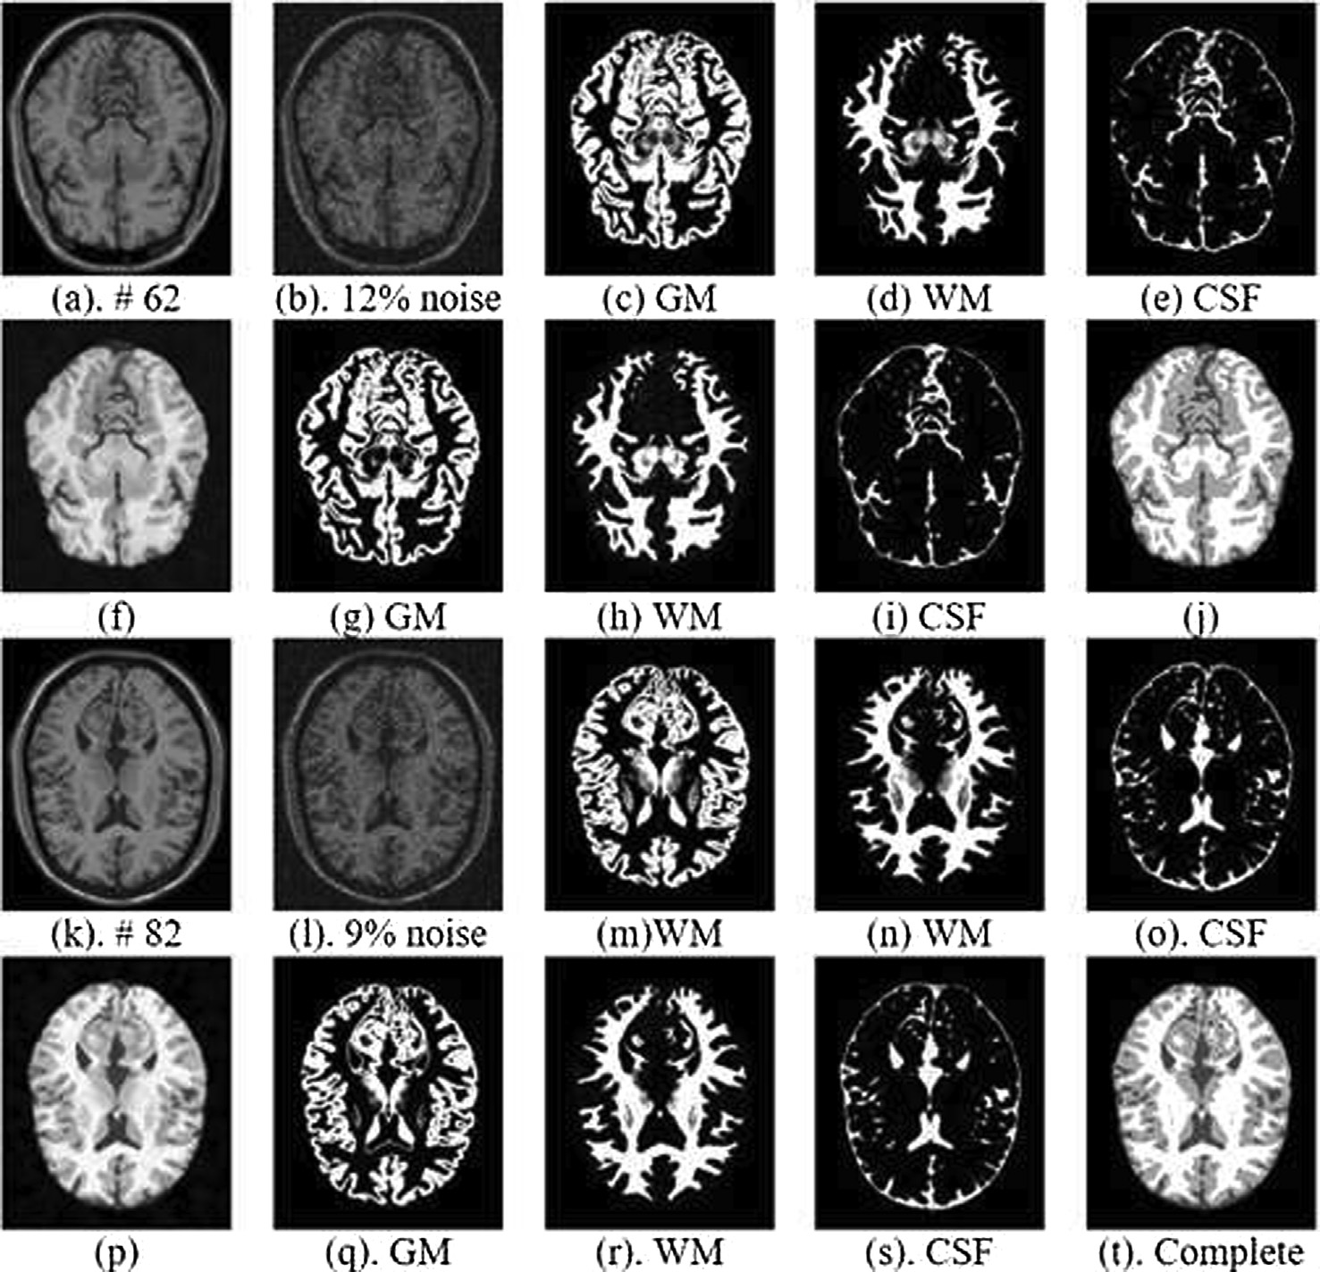

Fig. 5. Qualitative performance of proposed methodology on T1 simulated dataset, (a)–(e) and (k)–(o) are original images, noisy images, GM ground truth, WM ground truth and CSF ground truth respectively, while (f)–(j) and (p)–(t) are noise filtered & skull stripped, segmented GM, segmented WM, segmented CSF and segmented complete images by proposed methodology respectively.

decreases the performance and over-smoothed the edges. Thus in the case of noisy and edge pixels, it is better to use 5 × 5 window. The segmentation performance of the proposed methodology with different window sizes is shown in Fig. 4.

* 1. *Experimental setup*

The significance of the developed methodology has been tested and validated on two MRI datasets, for which performed a compre- hensive set of experiments under the following setup.

* In the first experiment, the paper has showed the accuracy of the proposed methodology on each dataset individually.
* In the second experiment, the paper has analyzed the robust- ness of the proposed methodology. For this purpose, a set of four sub-experiments were performed in order for showing the effectiveness of sub-components of the proposed methodol- ogy. In the first case, the performance of the proposed frame- work has been validated without performing preprocessing step and having intensity inhomogeneity. In the second case, the performance has been tested and validated without per- forming preprocessing step and without intensity inhomogene- ity. While, in the third case, the performance has been assessed with performing preprocessing step and without intensity inhomogeneity. Finally, in the last case, the performance of the proposed framework has been analyzed with performing

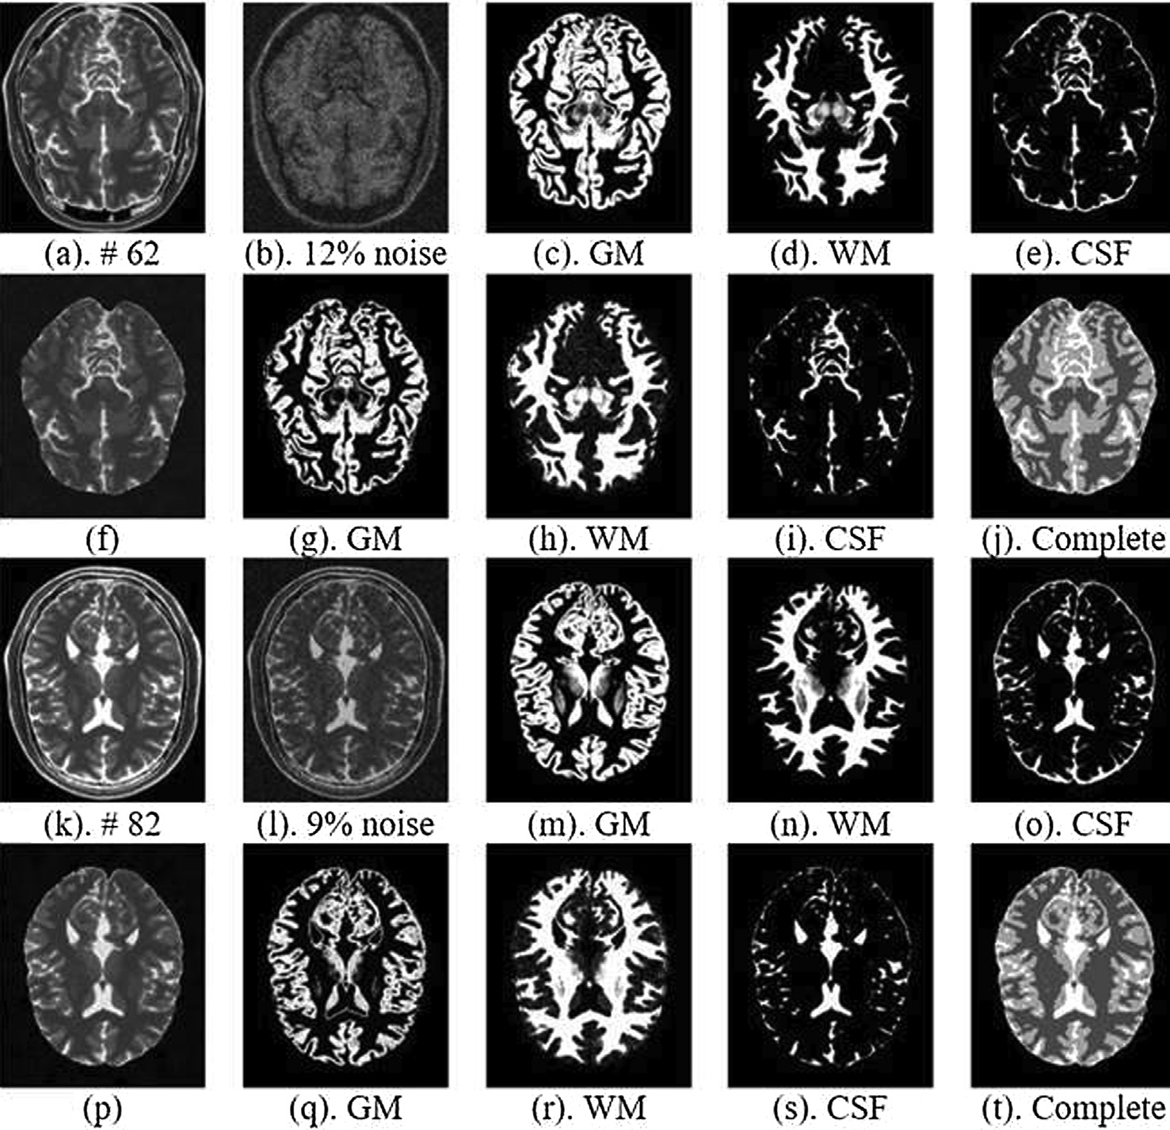

Fig. 6. Qualitative performance of proposed methodology on T2 simulated dataset, (a)–(e) and (k)–(o) are original images, noisy images, GM ground truth, WM ground truth and CSF ground truth respectively, while (f)–(j) and (p)–(t) are noise filtered & skull stripped, segmented GM, segmented WM, segmented CSF and segmented complete images by proposed methodology respectively.

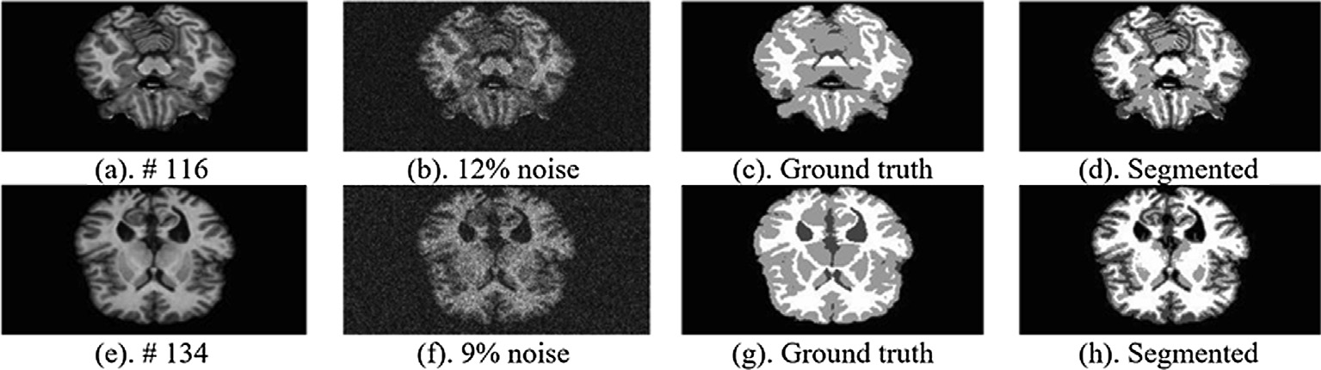

Fig. 7. Qualitative performance of proposed methodology on T1 real dataset, (a) and (e) are original images, (b) and (f) are noisy images, (c) and (g) are ground truth images, while (d) and (f) segmented images by proposed methodology.

preprocessing step and having intensity inhomogeneity in the images.

* + Lastly, in this experiment, the paper has performed a series of experiments for comparison in order to show the efficacy of the developed methodology. In this experiment, the significance of the developed methodology was compared against recent methods. The researcher borrowed the implementations for some of the methods, whereas for other methods, he has imple- mented his respective methods for fair comparison.

1. Results and discussion

In this section, the experimental results of the developed seg- mentation methodology named weighted spatial Fuzzy C-Means (wsFCM) are presented. The proposed segmentation method is tested both on simulated and real datasets to evaluate and validate the performance of the method. The results are shown in Table 1 and Figs. 5–10 respectively. Figs. 5–7 show the qualitative perfor- mance of the proposed segmentation methodology on simulated T1, simulated T2 and real T1 datasets images respectively at differ- ent noise levels. In order to get the accurate segmentation results, first the input image is processed for noise suppression and isola- tion of brain part from non-brain tissues to avoid the overlapping issue which can effect on the segmentation performance and causes to misclassification of the image objects. After performing processing step, the segmentation is performed by the proposed method wsFCM. Also, from the Figs. 5–7, it is obvious that the developed technique succeeded well in correcting and classifying the tissues classes of the images and the brain segmented classes have maximal similarity with reference images.

Edges plays significant role in making the image regions distinct and tracing the symptoms of diseases. Table 2 and Figs. 8–10 show the performance of the proposed segmentation methodology in preserving the edges and structural information on T1 simulated, T2 simulated and T1 real datasets with zooming views. Also, from Figs. 8–10, it is clear that the edges of the segmented images by the developed method have maximum similarity with the structure and edges of reference images (ground truth). This maximum similarity of edges of segmented images between proposed methodology and reference images clearly point towards the better preservation of the edges and structural information. It can be concluded by qualitative inspections of the images, the

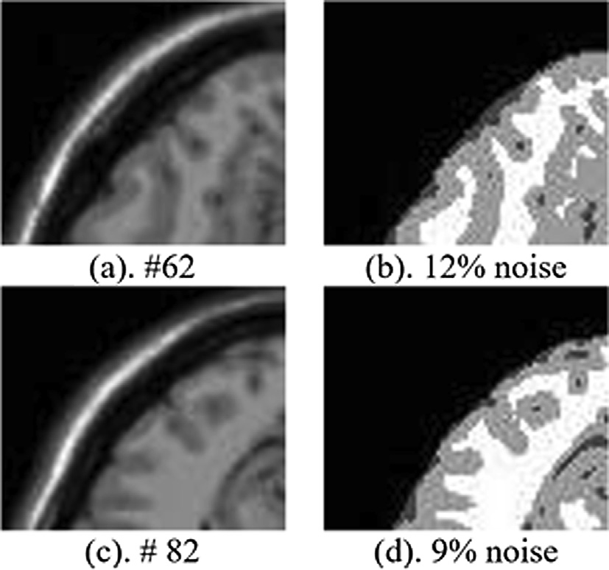

Fig. 8. Qualitative performance of proposed methodology in preserving edges on T1 simulated dataset having 20% intensity inhomogeneity with zooming view, (a) and

(c) are original images, (b) and (d) are segmented by proposed method by filtering 12% and 9% noise.

proposed algorithm produces a segmentation that accepts maxi- mal similarity with the ground truth and better preservation of the image features such as edges.

Tables 3–6 show the quantitative performance of the proposed segmentation method in preserving edges and structural detail in terms of structured similarity scores on simulated T1, simulated T2 and real T1 datasets images respectively at different noise levels ranging from 0% to 18%. First the edges of the reference and seg- mented (proposed method) images have been detected using Sobel filter (Sobel & Feldman, 1968) and compared the similarity of edges between reference and segmented images using SSIM. From Tables 1,2, it is obvious that the developed method preserves the sufficient edges information and retains the maximum structure of image at low and high noise levels which indicate the better sig- nificance of the proposed segmentation methodology in preserving edges.

From the qualitative and quantitative inspections/ results, it is observed that the developed segmentation method performs suffi- cient in segmenting the images, preserving edges and generates good results, sustains its performance at increasing levels of noise

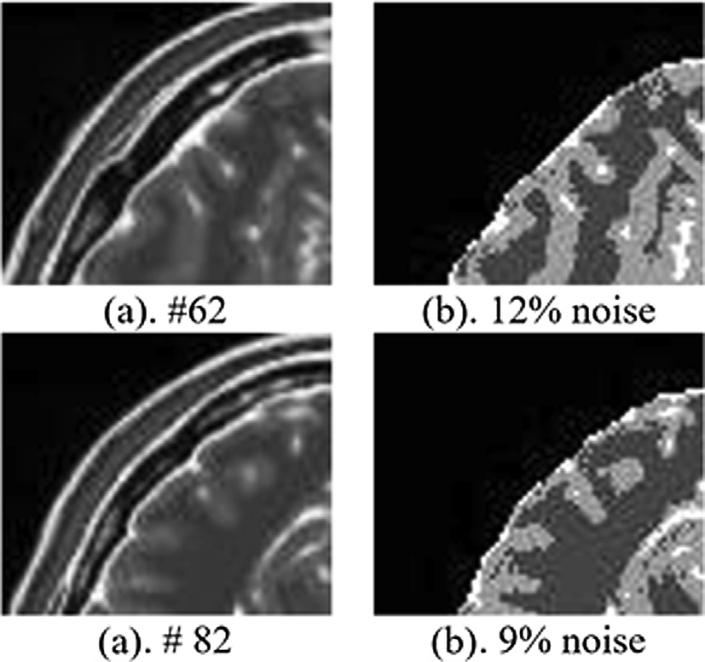

Fig. 9. Qualitative performance of proposed methodology in preserving edges on T2 simulated dataset having 20% intensity inhomogeneity with zooming view, (a) and

(c) are original images, (b) and (d) are segmented by proposed method by filtering 12% and 9% noise.

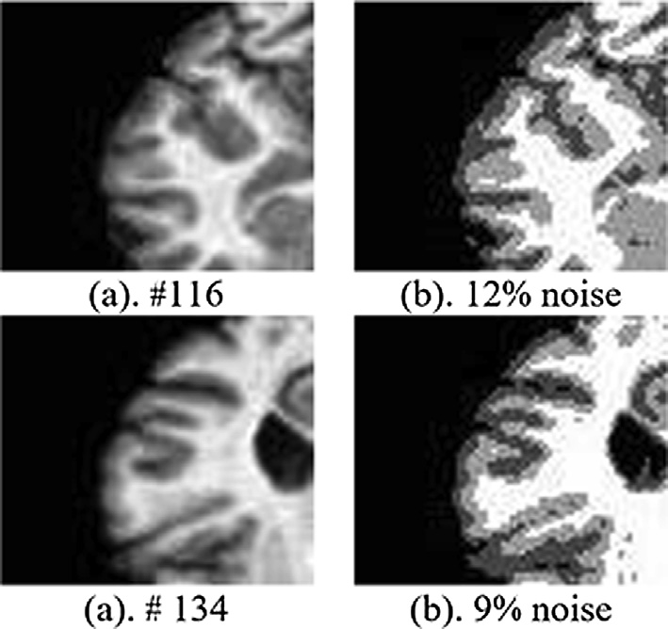

Fig. 10. Qualitative performance of proposed methodology in preserving edges on T1 real dataset image with zooming view, (a) and (c) are original images, while (b) and (d) are segmented by proposed method by filtering 12% and 9% noise.

and suitable for the segmentation of brain MRI. This is all achieved by preprocessing the image properly for handling noise and tissues overlapping issues. The proposed segmentation method also has the capability of handling intensity inhomogeneity, which occurs during image acquisition process by utilizing the spatial character- istics of the image. Therefore, it is obvious that the developed seg- mentation technique showed a significant performance on standard datasets. It is because, the proposed method first pre- processed the image. Then the three-dimensional context of the image is considered, utilized and integrated in the proposed seg- mentation method. On the basis of spatial context, weights are assigned to each neighboring pixel in each possible directions of a central pixel in the neighborhood which contribute to decrease the effect of noise itself as well as handling the intensity inhomo- geneities occurred during image acquisition process and based on

the directional weights, preserves the edges information. That is why the efficacy of the developed segmentation method is superior.

* 1. *Robustness of proposed methodology*

As mentioned before, in this experiment, four sub experiments has performed to show the robustness of the proposed methodol- ogy to dynamic environments. The detail of each experiment is given below.

Case1: Without Preprocessing and with IIH:

In this experiment, the preprocessing step for noise removal and handling tissues intensities overlapping is not performed. The overall results for this experiment are shown in Fig. 11 and in Table 7.

Table 2

Accuracy of the proposed segmentation methodology in terms of Dice Similarity Score on simulated T2-weighted dataset images with intensity inhomogeneity (IIH) 20%.

|  |  |  |  |  |  |  |  |  |  |  |  |
| --- | --- | --- | --- | --- | --- | --- | --- | --- | --- | --- | --- |
| Slice | Tissues |  |  |  |  | Noise Level |  | | | | |
|  |  | 0% | 1% | 3% | 5% | 7% | 9% | 12% | 15% | 18% |  |
| #62 | GM | 0.9687 | 0.9639 | 0.9602 | 0.9588 | 0.9522 | 0.9450 | 0.9384 | 0.9315 | 0.9261 |  |
|  | WM | 0.9701 | 0.9684 | 0.9627 | 0.9604 | 0.9579 | 0.9547 | 0.9500 | 0.9453 | 0.9376 |  |
|  | CSF | 0.9532 | 0.9471 | 0.9406 | 0.9387 | 0.9321 | 0.9257 | 0.9207 | 0.9156 | 0.9111 |  |
| #82 | GM | 0.9677 | 0.9640 | 0.9614 | 0.9573 | 0.9524 | 0.9479 | 0.9407 | 0.9368 | 0.9386 |  |
|  | WM | 0.9713 | 0.9681 | 0.9645 | 0.9618 | 0.9587 | 0.9534 | 0.9487 | 0.9451 | 0.9413 |  |
|  | CSF | 0.9549 | 0.9522 | 0.9389 | 0.9357 | 0.9316 | 0.9284 | 0.9224 | 0.9184 | 0.9072 |  |

Table 3

Accuracy of the Proposed Segmentation methodology in terms of Dice Similarity Score on real T1-weighted dataset images.

|  |  |  |  |  |  |  |  |  |  |  |  |
| --- | --- | --- | --- | --- | --- | --- | --- | --- | --- | --- | --- |
| Slice | Tissues |  |  |  |  | Noise Level |  | | | | |
|  |  | 0% | 1% | 3% | 5% | 7% | 9% | 12% | 15% | 18% |  |
| #116 | GM | 0.9707 | 0.9682 | 0.9642 | 0.9614 | 0.9566 | 0.9531 | 0.9497 | 0.9423 | 0.9367 |  |
|  | WM | 0.9759 | 0.9713 | 0.9671 | 0.9623 | 0.9568 | 0.9577 | 0.9462 | 0.9426 | 0.9385 |  |
|  | CSF | 0.9486 | 0.9445 | 0.9413 | 0.9393 | 0.9354 | 0.9308 | 0.9288 | 0.9211 | 0.9162 |  |
| #134 | GM | 0.9717 | 0.9671 | 0.9642 | 0.9582 | 0.9546 | 0.9523 | 0.9382 | 0.9218 | 0.9116 |  |
|  | WM | 0.9804 | 0.9766 | 0.9719 | 0.9673 | 0.9633 | 0.9615 | 0.9584 | 0.9525 | 0.9463 |  |
|  | CSF | 0.9523 | 0.9489 | 0.9471 | 0.9433 | 0.9386 | 0.9353 | 0.9310 | 0.9254 | 0.9186 |  |

Table 4

SSIM based significance of the developed segmentation methodology in preserving edges on simulated T1-weighted images.

|  |  |  |  |  |  |  |  |  |  |  |
| --- | --- | --- | --- | --- | --- | --- | --- | --- | --- | --- |
| Slice |  |  |  |  | Noise Level |  | | | | |
|  | 0% | 1% | 3% | 5% | 7% | 9% | 12% | 15% | 18% |  |
| #62 | 0.9713 | 0.9691 | 0.9532 | 0.9471 | 0.9384 | 0.9246 | 0.9169 | 0.9019 | 0.8938 |  |
| #82 | 0.9761 | 0.9627 | 0.9569 | 0.9491 | 0.9381 | 0.9303 | 0.9241 | 0.9109 | 0.8856 |  |

Table 5

SSIM based significance of the developed segmentation methodology in preserving edges on simulated T2-weighted images.

|  |  |  |  |  |  |  |  |  |  |  |
| --- | --- | --- | --- | --- | --- | --- | --- | --- | --- | --- |
| Slice |  |  |  |  | Noise Level |  | | | | |
|  | 0% | 1% | 3% | 5% | 7% | 9% | 12% | 15% | 18% |  |
| #62 | 0.9685 | 0.9625 | 0.9543 | 0.9432 | 0.9311 | 0.9261 | 0.9137 | 0.9016 | 0.8915 |  |
| #82 | 0.9693 | 0.9619 | 0.9557 | 0.9449 | 0.9298 | 0.9221 | 0.9187 | 0.9033 | 0.8942 |  |

Table 6

SSIM based significance of the developed segmentation methodology in preserving edges on real T1-weighted images.

|  |  |  |  |  |  |  |  |  |  |  |
| --- | --- | --- | --- | --- | --- | --- | --- | --- | --- | --- |
| Slice |  |  |  |  | Noise Level |  | | | | |
|  | 0% | 1% | 3% | 5% | 7% | 9% | 12% | 15% | 18% |  |
| #116 | 0.9769 | 0.9724 | 0.9681 | 0.9573 | 0.9518 | 0.9354 | 0.9204 | 0.9133 | 0.9010 |  |
| #134 | 0.9748 | 0.9717 | 0.9669 | 0.9491 | 0.9407 | 0.9383 | 0.9241 | 0.9109 | 0.8986 |  |

It is clear from Fig. 11 and in Table 7 that the preprocessing step for handling noise and tissues overlapping issues has an important role in achieving best accuracy for the proposed method. This is because the noise in images has direct influence on the quality and accuracy of the segmentation. Moreover, Fig. 11 also presents

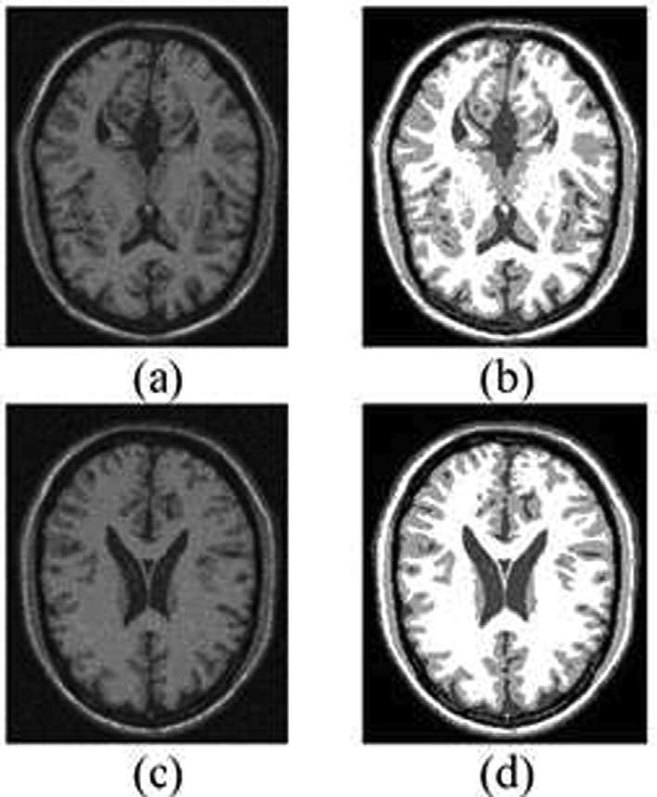

Fig. 11. Qualitative results of the proposed methodology without image prepro- cessing and with intensity inhomogeneity (IIH), (a) and (c) are original images with noise, (b) and (d) segmented images.

Table 7

Dice Similarity based quantitative results of the proposed methodology without preprocessing and with intensity inhomogeneity (IIH) using simulated T1-weighted images dataset.

Environment Slice Segmentation Accuracy Without Preprocessing and IIH = 20% #77 0.8885

#93 0.8947

Average 0.8916

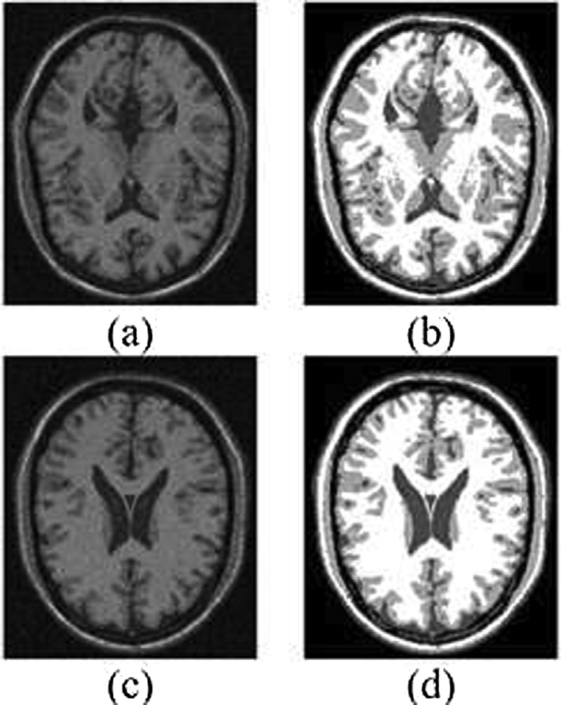

Fig. 12. Qualitative results of the proposed methodology with image preprocessing and without intensity inhomogeneity (IIH), (a) and (c) are original images with noise, (b) and (d) segmented images.

Table 8

Dice Similarity based quantitative results of the proposed methodology without preprocessing and without intensity inhomogeneity (IIH) using simulated T1- weighted images dataset.

|  |  |  |
| --- | --- | --- |
| Environment | Slice | Segmentation Accuracy |
| Without Preprocessing and IIH = 0% | #77 | 0.8902 |
|  | #93 | 0.8940 |
|  | Average | 0.8921 |

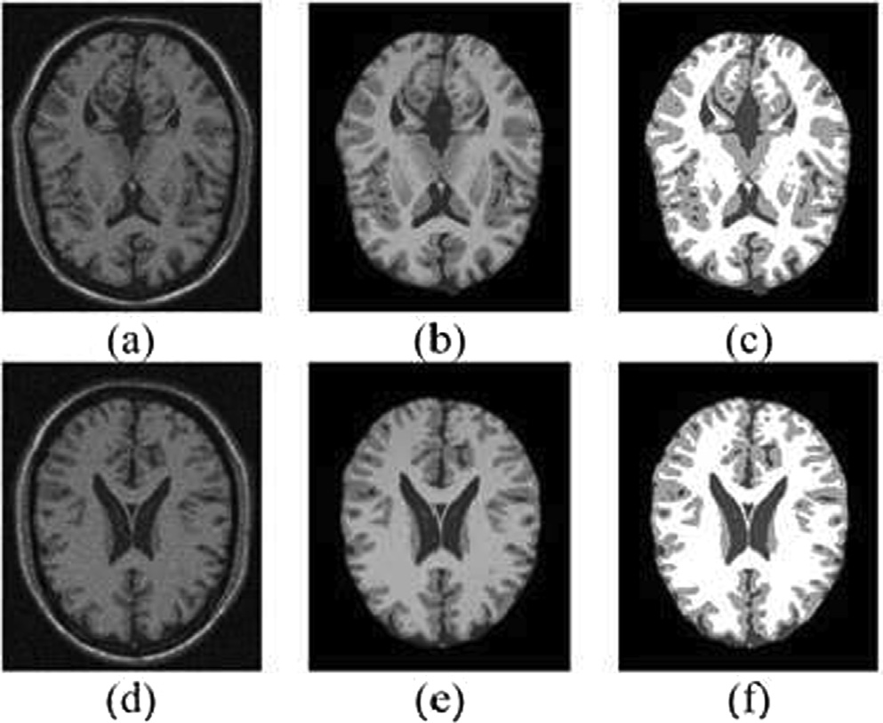

Fig. 13. Qualitative results of the proposed methodology with image preprocessing and with intensity inhomogeneity (IIH), (a) and (d) are original images with noise,

(b) and (e) are preprocessed images and, (c) and (f) segmented images.

Table 9

Dice Similarity based quantitative results of the proposed methodology with preprocessing and with intensity inhomogeneity (IIH = 20%) using simulated T1- weighted images dataset.

Environment Slice Segmentation Accuracy With Preprocessing and IIH = 20% #77 0.9234

#93 0.9320

Average 0.9255

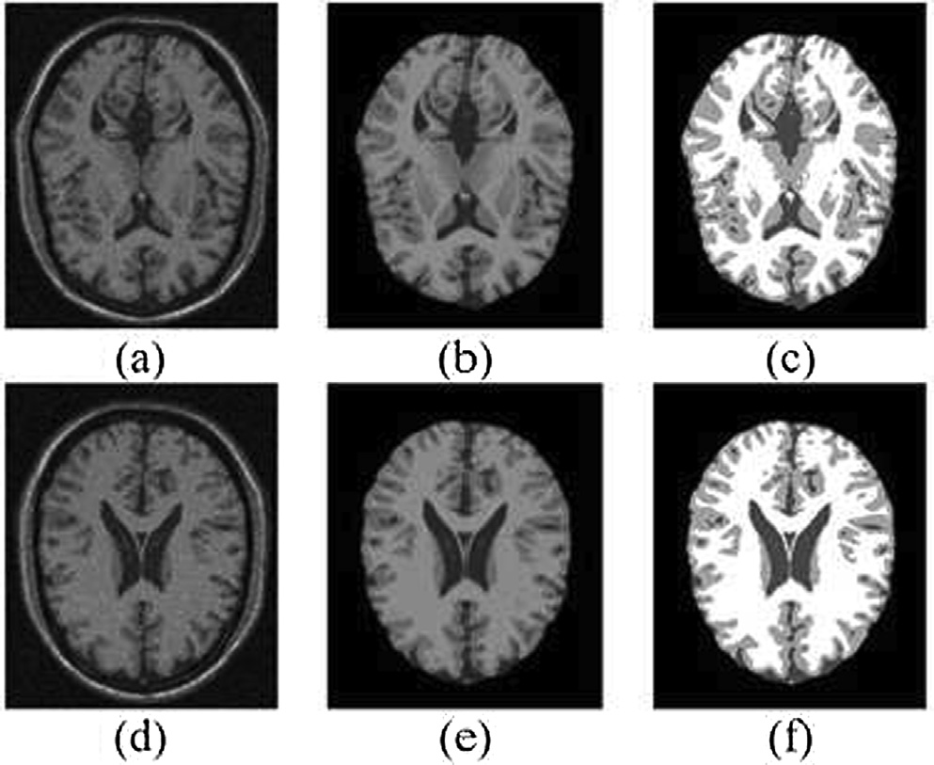

Fig. 14. Qualitative results of the proposed methodology with image preprocessing and with intensity inhomogeneity (IIH), (a) and (c) are original images with noise,

(b) and (d) segmented images.

Table 10

Dice Similarity based quantitative results of the proposed methodology with preprocessing and with intensity inhomogeneity (IIH = 0%) using simulated

T1-weighted images dataset.

that the noise affects the quality of the segmented images and the homogeneous regions still contain the noisy pixels. The noise also exists on the boundaries of the regions due to which the regions

boundaries are not clear and overlapping. Also the accuracy of

|  |  |  |
| --- | --- | --- |
| Environment | Slice | Segmentation Accuracy |
| With Preprocessing and IIH = 0% | #77 | 0.9209 |
|  | #93 | 0.9301 |
|  | Average | 0.9277 |

the proposed segmentation method is suffered due to noise as given in Table 7. On the other hand, intensity inhomogeneity issue degrades image quality and causes to reproduce the poor segmen- tation. However, the developed method has the inbuilt capability of dealing with intensity inhomogeneity and handling other irreg-

Table 11

Quantitative comparison of proposed methodology with previous different methods on 51 T1-weighted simulated dataset images in term of cluster validity functions.

Image Volume Method Clusters Validation

|  |  |  |  |  |  |
| --- | --- | --- | --- | --- | --- |
|  | | P*c* | P*e* | *p* |  |
| IIH = 40%, Noise = 9% | FCM | 0.803 | 0.378 | 71.176 |  |
|  | sFCM | 0.897 | 0.180 | 74.351 |  |
|  | FGFCM | 0.584 | 0.777 | 71.217 |  |
|  | ASIFC | 0.843 | 0.290 | 75.580 |  |
|  | csFCM | 0.943 | 0.096 | 76.670 |  |
|  | wsFCM | 0.955 | 0.068 | 78.751 |  |
| IIH = 20%, Noise = 9% | FCM | 0.803 | 0.378 | 71.612 |  |
|  | sFCM | 0.897 | 0.180 | 75.023 |  |
|  | FGFCM | 0.600 | 0.748 | 71.564 |  |
|  | ASIFC | 0.845 | 0.299 | 76.428 |  |
|  | csFCM | 0.945 | 0.094 | 77.594 |  |
|  | wsFCM | 0.961 | 0.062 | 79.014 |  |
| IIH = 40%, Noise = 7% | FCM | 0.823 | 0.343 | 75.656 |  |
|  | sFCM | 0.910 | 0.157 | 76.943 |  |
|  | FGFCM | 0.592 | 0.762 | 74.782 |  |
|  | ASIFC | 0.844 | 0.309 | 76.980 |  |
|  | csFCM | 0.947 | 0.089 | 77.509 |  |
|  | wsFCM | 0.966 | 0.063 | 79.339 |  |
| IIH = 20%, Noise = 7% | FCM | 0.823 | 0.343 | 75.653 |  |
|  | sFCM | 0.912 | 0.153 | 77.723 |  |
|  | FGFCM | 0.613 | 0.724 | 75.380 |  |
|  | ASIFC | 0.866 | 0.294 | 77.072 |  |
|  | csFCM | 0.949 | 0.086 | 78.493 |  |
|  | wsFCM | 0.969 | 0.058 | 80.026 |  |

Table 12

Quantitative comparison of proposed methodology with previous different methods on 51 T1-weighted simulated datasets images in term of average segmentation accuracy.

Image Volume Method Segmentation Accuracy (SA) CSF GM WM

IIH = 40%, Noise = 9% FCM 0.791 0.786 0.820

sFCM 0.832 0.863 0.869

FGFCM 0.777 0.782 0.878

ASIFC 0.852 0.866 0.891

csFCM 0.880 0.877 0.921

wsFCM 0.909 0.917 0.942

IIH = 20%, Noise = 9% FCM 0.797 0.792 0.824

sFCM 0.831 0.872 0.890

FGFCM 0.779 0.783 0.894

ASIFC 0.856 0.885 0.926

csFCM 0.884 0.890 0.947

wsFCM 0.913 0.935 0.957

IIH = 40%, Noise = 7% FCM 0.843 0.855 0.847

sFCM 0.888 0.896 0.909

FGFCM 0.853 0.836 0.912

ASIFC 0.890 0.899 0.913

csFCM 0.903 0.902 0.933

wsFCM 0.917 0.931 0.944

IIH = 20%, Noise = 7% FCM 0.847 0.858 0.852

sFCM 0.889 0.905 0.935

FGFCM 0.856 0.844 0.932

ASIFC 0.891 0.907 0.939

csFCM 0.902 0.915 0.959

wsFCM 0.919 0.942 0.961

ularities due to which the method still sustains its accuracy but not achieved much better results due to noise effect. It can be con- cluded that the preprocessing of image is an important step of the method and has a significant role in achieving the best accu- racy of the proposed segmentation method.

Case2: Without Preprocessing and without IIH:

In this experiment, preprocessing step is not performed and presented image to proposed segmentation method which contain no inhomogeneity. The overall results for this experiment are rep- resented in Fig. 12 and Table 8.

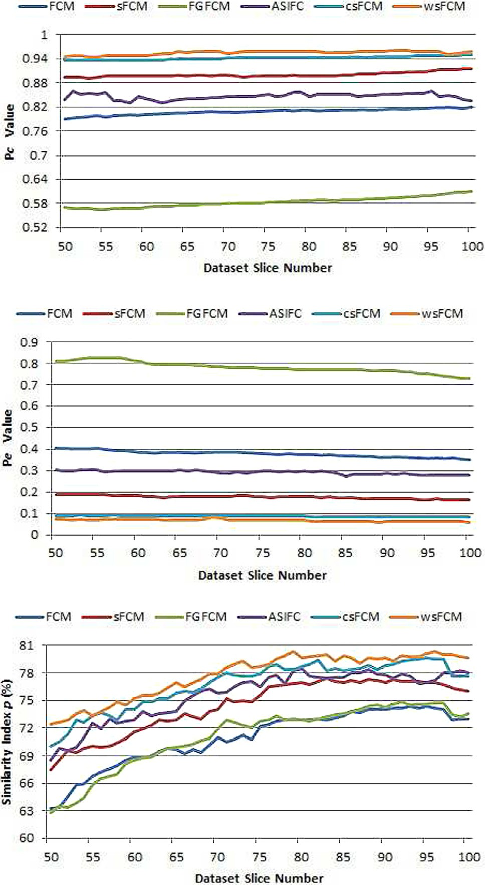

Fig. 15. Quantitative comparison of proposed methodology with previous different methods on 51 T1-weighted simulated dataset images in term of average segmentation accuracy (Top) CSF, (Middle) GM and (Bottom) WM.

From Fig. 12 and Table 8, it can be observed that the prepro- cessing step has a significant role in achieving the best accuracy for the proposed method. This is because the effect of noise is not first properly reduced from the images due to which the visual quality of the segmentation and overall accuracy of the segmentation method is affected. The performance of the pro- posed method is satisfactory due to capability of handling imag- ing irregularities if exist in the images but not much better as the noise is not removed properly. So, it can be concluded that the processing of image is necessary in the segmentation frame- work, which plays an essential role in achieving the better accu- racy and results.

Case3: With Preprocessing and with IIH:

Fig. 13 and Table 9 show the qualitative and quantitative out- comes of the proposed segmentation method with performing pre- processing step and its role in the methodology in achieving the best accuracy. From Fig. 13, it can be perceived from segmented images that the proposed segmentation method reproduces the good segmentation quality with homogeneous regions having sharp and clear regions boundaries. The reason behind this is the proper noise suppression and isolation of brain and non-brain parts and presenting the noise free image to the segmentation method. The preprocessing of image as well as utilization of the spatial characteristics of the images adds value to the proposed segmentation methodology in achieving the best accuracy of the segmentation. Also, from the Fig. 13 and Table 9, it can be con- cluded that the performance of the proposed segmentation methodology is reliant on resolving noise and tissue intensities overlapping issues properly along with other inbuilt capabilities of intensity inhomogeneity handling in reproducing good segmen- tation and achieving best accuracy.

From Fig. 13 and Table 9, it can be observed that the prepro- cessing step has a significant role in achieving the best accuracy for the proposed method. This is because the effect of noise is not first properly reduced from the images due to which the visual quality of the segmentation and overall accuracy of the segmentation method is affected. The performance of the pro- posed method is satisfactory due to capability of handling imag- ing irregularities if exist in the images but not much better as the noise is not removed properly. So, it can be concluded that the processing of image is necessary in the segmentation frame- work, which plays an essential role in achieving the better accu- racy and results.

Case4: With Preprocessing and without IIH:

Fig. 14 and Table 10 illustrate the significant function of the pre- processing step in achieving the best qualitative and quantitative results of proposed segmentation methodology. This is because the noise is suppressed properly from the images and isolated the non-brain parts and capability of the proposed method itself in dealing with the intensity inhomogeneity issue by considering and incorporating the spatial context of the image.

As can be observed from Fig. 14, each region in the segmented images is distinct with clear boundaries and free of noise and the overall accuracy of the proposed methodology is much better as given in Table 10. From this sub experiment, it can be concluded that the preprocessing of images is a very important step of the methodology, which strengthens the performance of the segmen- tation methodology in achieving best accuracy.

Based on the above experimentations and results achieved, it has been proved that the proposed segmentation methodology showed best performance in the presence of imaging artifacts and intensity inhomogeneity as well as in the absence of imaging artifacts and intensity inhomogeneity. It is clear from these exper- iments that the proposed method sustained its accuracy in noisy and noise free environments, which means that the proposed methodology is more robust to dynamic environments.

* 1. *Comparison*

The article has discussed and compared the results attained from the developed approach against existing methods showed in Table 11 and Fig. 15. We attained these results using brain images of MRI along with 7%–9% of noise level and 20%–40% inten- sity inhomogeneity on 51 simulated dataset T1-weighted images (pieces 50–100). Fig. 15 shows a comparison of the proposed methodology with existing methods, that is, sFCM, FGFCM, ASIFC and csFCM in terms of cluster validity functions like partition coef- ficient (*Pc*), partition entropy (*Pe*) and similarity index (*p*) over 51 T1-weighted simulated dataset images (50–100). Also from Fig. 15, it can be perceived that the developed technique performs well than existing methods and sustains its superiority which clearly points towards the better performance. Fig. 16 shows the quantifiable relative values of segmentation of gray matters (GM), white matters (WM) and cerebrospinal fluid (CSF) tissues of proposed methodology with previous different methods fuzzy c-means (FCM), spatial fuzzy c-means (sFCM), fuzzy generalized

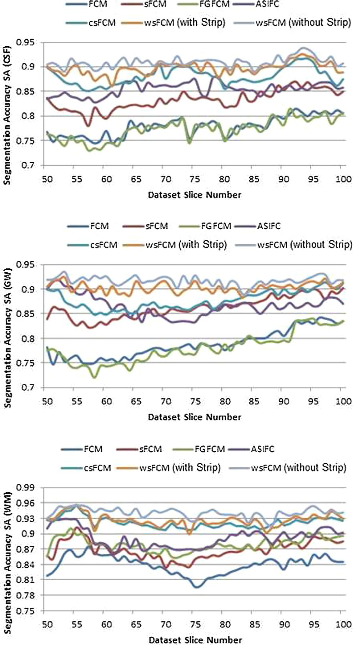

Fig. 16. Quantitative comparison of proposed methodology with previous different methods on 51 T1-weighted simulated dataset images in term of average segmentation accuracy (Top) CSF, (Middle) GM and (Bottom) WM without strip.

fuzzy c-means (FGFCM), adaptive spatial information fuzzy clus- tering (ASIFC) and conditional spatial fuzzy c-means (csFCM) on

51 T1-weighted simulated dataset images (slices 50–100) with 9% noise and 40% intensity inhomogeneity. It is clear that the developed technique consistently outperforms than the competi- tors state-of-the-art algorithms while segmenting the tissues regions. It can also be observed that the previous algorithms per-

form better on some images while the proposed method perfor- mance is better and consistent on all tested images. The results show that overall performance of proposed method is constantly better although the efficacy degrade if brain and non-brain parts do not correctly separated.).

Table 11 shows a comparison of the developed approach along with previous methods, that is, FCM, sFCM, FGFCM, ASIFC and

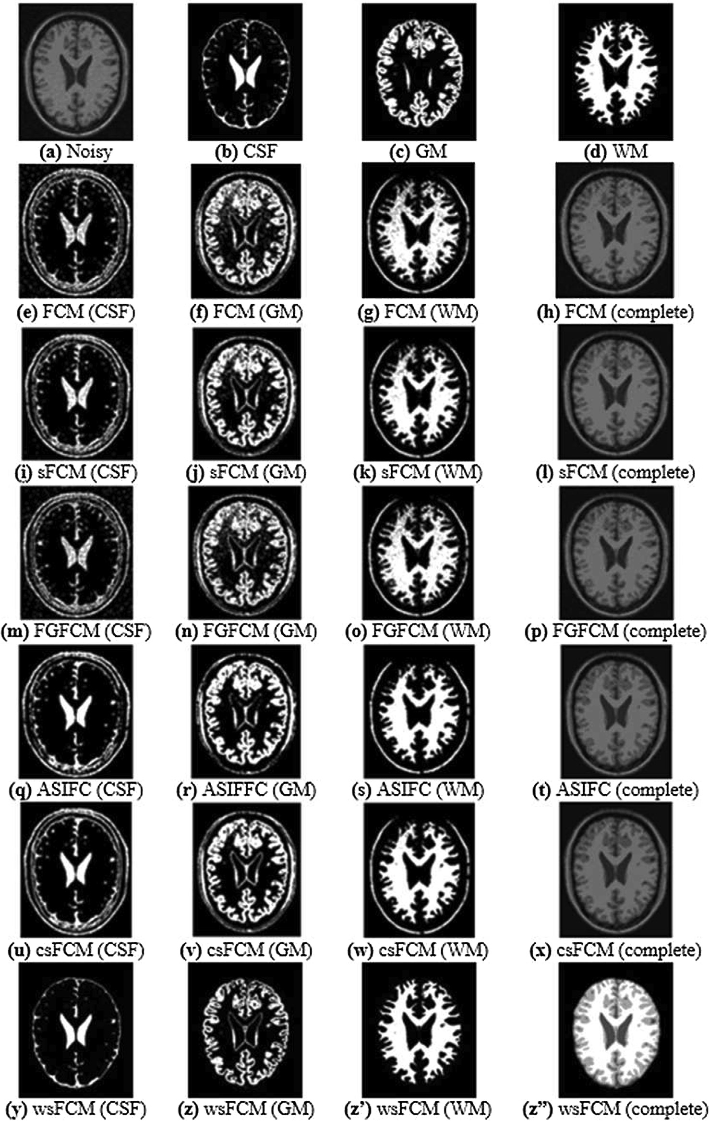

Fig. 17. Sample segmentation results of CSF, GM, WM against state of the art techniques on a T1-weighted images in simulated dataset (piece No. 95) with 9% level of noise and 40% inhomogeneity, (a): Original noisy image; (b)–(d): Ground Truths; (e)–(h): FCM; (i)–(l): sFCM; (m)–(p): FGFCM; (q)–(t): ASIFC; (u)–(x): csFCM; (y)–(z): developed methodology (wsFCM).

csFCM in terms of averaged values of diverse cluster rationality functions such as partition coefficient (Pc), partition entropy (*Pe*) and similarity index (*P*) over 51 T1-weighted simulated dataset images (50–100). From Table 11, it can be observed that the aver- age values of Pc and Pe generated by new method are near to 1 and 0 correspondingly under the presence of highest values of noise and inhomogeneity, whereas, the performance of the other com- petitor methods is not well. In each dataset images, the value of similarity index p of the proposed method is increased than exist- ing methods which shows that the proposed method outperforms. Table 12 also shows the quantitative comparisons of proposed method with sFCM, FGFCM, ASIFC and csFCM in terms of segmen- tation accuracy of GM, WM and CSF regions over 51 T1-weighted simulated dataset images (slices 50–100) with 7%–9% level of noise and 20%–40% intensity inhomogeneity. From the results, we can observe that the developed technique produces significant results against recent methods. The segmentation accuracy of the previous algorithms suffers as the intensity inhomogeneity in the images

increases.

Fig. 17 presents the qualitative assessment of the developed approach along with previous methodologies on T1-weighted sim- ulated dataset (slice 95) with noise level 9% and intensity inhomo- geneity 40%. It is obvious that the existing approaches consistently faced certain problem in which some tissues incorrectly catego- rized. Hence, these approaches did not focus on eliminating the non-brain portions from brain portions because of that intensities overlying happen, which degrade the accuracy of segmentation. Out of standard methods, csFCM shows significant performance against existing methods. On the other side, the developed methodology has come advantages such as noise removal in pre- processing, separation of brain and non-brain materials, edge con- servation, and mechanism to correctly handle intensity inhomogeneity, because of these advantage, the our approach showed significant performance against existing techniques.

1. Conclusions

In this paper, a robust clustering based technique weighted spa- tial fuzzy c-means (wsFCM) by utilizing spatial context of images has been developed for the segmentation of brain MRI. In the pro- posed algorithm, a spatial function is proposed and incorporated in the membership function of regular fuzzy c-means technique. The spatial function considers and utilizes the spatial characteristics of the image and assigns weights to the neighbors according to their correlation with central pixel in the neighborhood window. The incorporation of spatial function into membership function improves the robustness of the algorithm to noise and intensity inhomogeneity thus providing excellent outcomes of segmenta- tion. The spatial function strengthens the membership function which is helpful in preserving the edges of the regions in the image. The proposed method is tested on two publicly available standard datasets, BrainWeb simulated and IBSR real. A compre- hensive set of experimentation is performed in order to evaluate and validate performance of proposed algorithm through standard metrics. The results showed that the performance of the proposed method is robust to noise and deals with the intensity inhomo- geneity issue with a better and improved way. The performance of the developed methodology is compared against recent algo- rithms and performance found to be superior to existing tech- niques in this domain.

Acknowledgment

This work was supported by the Jouf University, Sakaka, Aljouf, Kingdom of Saudi Arabia under the registration No. 37/438.

References

1. [Du Y, Lai P, Leung C, Pong P. Design of superparamagnetic nanoparticles for](http://refhub.elsevier.com/S1110-8665(19)30182-3/h0005) [magnetic particle imaging (MPI). Int J Mol Sci 2013;14(9):18682–710](http://refhub.elsevier.com/S1110-8665(19)30182-3/h0005).
2. [Yang J, Fan J, Ai D, Zhou S, Tang S, Wang Y. Brain MR image denoising for Rician](http://refhub.elsevier.com/S1110-8665(19)30182-3/h0010) [noise using pre-smooth non-local means filter. Biomed Eng Online 2015;14](http://refhub.elsevier.com/S1110-8665(19)30182-3/h0010) [(1):2](http://refhub.elsevier.com/S1110-8665(19)30182-3/h0010).
3. Despotovic I, Goossens B, Philips W. Mri segmentation of the human brain: challenges, methods, and applications. Computational and mathematical methods in medicine; 2015..
4. Long-term study plays down risk of brain problems in HIV-positive patients. [http://www.aidsmap.com/Long-term-study-plays-down-risk-of-brain-](http://www.aidsmap.com/Long-term-study-plays-down-risk-of-brain-problems-in-HIV-positive-patients/page/1423648) [problems-in-HIV-positive-patients/page/1423648](http://www.aidsmap.com/Long-term-study-plays-down-risk-of-brain-problems-in-HIV-positive-patients/page/1423648) [accessed: 2019-03-20].
5. [Kumar PS, Kumar PG. Performance analysis of brain tumor diagnosis based on](http://refhub.elsevier.com/S1110-8665(19)30182-3/h0025) [soft computing techniques. Am J Appl Sci 2014;11(2):329–36](http://refhub.elsevier.com/S1110-8665(19)30182-3/h0025).
6. [Miao Z, Lin X, Liu C. Automatic segmentation of brain tissue based on improved](http://refhub.elsevier.com/S1110-8665(19)30182-3/h0030) [fuzzy c means clustering algorithm. J Biomed Sci Eng 2011;4:100–4](http://refhub.elsevier.com/S1110-8665(19)30182-3/h0030).
7. Lewis T, Writer S. Human brain: Facts, functions & anatomy; 2016. [accessed: 2019-03-20].
8. [Riad AM, Atwan A, El HM, Mostafa RR, Elminir HK, Mastorakis N. A new](http://refhub.elsevier.com/S1110-8665(19)30182-3/h0040) [approach for segmentation of brain MR image. Proceedings of the WSEAS](http://refhub.elsevier.com/S1110-8665(19)30182-3/h0040) [International Conference on Environment, Medicine and Health Sciences, vol.](http://refhub.elsevier.com/S1110-8665(19)30182-3/h0040) [5125. p. 74–83](http://refhub.elsevier.com/S1110-8665(19)30182-3/h0040).
9. [Adhikari SK, Sing JK, Basu DK, Nasipuri M. Conditional spatial fuzzy c-means](http://refhub.elsevier.com/S1110-8665(19)30182-3/h0045) [clustering algorithm for segmentation of MRI images. Appl Soft Comput](http://refhub.elsevier.com/S1110-8665(19)30182-3/h0045) [2015;34:758–69](http://refhub.elsevier.com/S1110-8665(19)30182-3/h0045).
10. [Haralick RM, Shapiro LG. Image segmentation techniques. Computer Vision,](http://refhub.elsevier.com/S1110-8665(19)30182-3/h0050) [Graphics, and Image Processing 1985;29(1):100–32](http://refhub.elsevier.com/S1110-8665(19)30182-3/h0050).
11. Roy S, Nag S, Maitra IK, Bandyopadhyay SK. A review on automated brain tumor detection and segmentation from MRI of brain. arXiv preprint arXiv:1312.6150.
12. [Liu J, Li M, Wang J, Wu F, Liu T, Pan Y. A survey of MRI-based brain tumor](http://refhub.elsevier.com/S1110-8665(19)30182-3/h0060) [segmentation methods. Tsinghua Sci Technol 2014;19(6):578–95](http://refhub.elsevier.com/S1110-8665(19)30182-3/h0060).
13. [Pham DL. Fuzzy clustering with spatial constraints. Proceedings. International](http://refhub.elsevier.com/S1110-8665(19)30182-3/h0065) [Conference on Image Processing, vol. 2. IEEE; 2002. pp. II–II](http://refhub.elsevier.com/S1110-8665(19)30182-3/h0065).
14. [Shen S, Sandham W, Granat M, Sterr A. MRI fuzzy segmentation of brain tissue](http://refhub.elsevier.com/S1110-8665(19)30182-3/h0070) [using neighborhood attraction with neural-network optimization. IEEE Trans](http://refhub.elsevier.com/S1110-8665(19)30182-3/h0070) [Inf Technol Biomed 2005;9(3):459–67](http://refhub.elsevier.com/S1110-8665(19)30182-3/h0070).
15. [Chuang K-S, Tzeng H-L, Chen S, Wu J, Chen T-J. Fuzzy c-means clustering with](http://refhub.elsevier.com/S1110-8665(19)30182-3/h0075) [spatial information for image segmentation. Comput Med Imaging Graph](http://refhub.elsevier.com/S1110-8665(19)30182-3/h0075) [2006;30(1):9–15](http://refhub.elsevier.com/S1110-8665(19)30182-3/h0075).
16. [Cai W, Chen S, Zhang D. Fast and robust fuzzy c-means clustering algorithms](http://refhub.elsevier.com/S1110-8665(19)30182-3/h0080) [incorporating local information for image segmentation. Pattern Recognition](http://refhub.elsevier.com/S1110-8665(19)30182-3/h0080) [2007;40(3):825–38](http://refhub.elsevier.com/S1110-8665(19)30182-3/h0080).
17. [Jiang X-L, Wang Q, He B, Chen S-J, Li B-L. Robust level set image segmentation](http://refhub.elsevier.com/S1110-8665(19)30182-3/h0085) [algorithm using local correntropy-based fuzzy c-means clustering with spatial](http://refhub.elsevier.com/S1110-8665(19)30182-3/h0085) [constraints. Neurocomputing 2016;207:22–35](http://refhub.elsevier.com/S1110-8665(19)30182-3/h0085).
18. [Yu H-Y, Fan J-L. Three-level image segmentation based on maximum fuzzy](http://refhub.elsevier.com/S1110-8665(19)30182-3/h0090) [partition entropy of 2-d histogram and quantum genetic algorithm. In:](http://refhub.elsevier.com/S1110-8665(19)30182-3/h0090) [International Conference on Intelligent Computing. Springer; 2008. p. 484–93](http://refhub.elsevier.com/S1110-8665(19)30182-3/h0090).
19. [Wang Z, Song Q, Soh YC, Sim K. An adaptive spatial information-theoretic](http://refhub.elsevier.com/S1110-8665(19)30182-3/h0095) [fuzzy clustering algorithm for image segmentation. Comput Vis Image Underst](http://refhub.elsevier.com/S1110-8665(19)30182-3/h0095) [2013;117(10):1412–20](http://refhub.elsevier.com/S1110-8665(19)30182-3/h0095).
20. [Caldairou B, Passat N, Habas PA, Studholme C, Rousseau F. A non-local fuzzy](http://refhub.elsevier.com/S1110-8665(19)30182-3/h0100) [segmentation method: application to brain MRI. Pattern Recogn 2011;44](http://refhub.elsevier.com/S1110-8665(19)30182-3/h0100) [(9):1916–27](http://refhub.elsevier.com/S1110-8665(19)30182-3/h0100).
21. [Zhao F, Jiao L, Liu H. Fuzzy c-means clustering with non local spatial](http://refhub.elsevier.com/S1110-8665(19)30182-3/h0105) [information for noisy image segmentation. Front Comput Sci China 2011;5](http://refhub.elsevier.com/S1110-8665(19)30182-3/h0105) [(1):45–56](http://refhub.elsevier.com/S1110-8665(19)30182-3/h0105).
22. [Ji Z-X, Sun Q-S, Xia D-S. A modified possibilistic fuzzy c-means clustering](http://refhub.elsevier.com/S1110-8665(19)30182-3/h0110) [algorithm for bias field estimation and segmentation of brain mr image.](http://refhub.elsevier.com/S1110-8665(19)30182-3/h0110) [Comput Med Imaging Graph 2011;35(5):383–97](http://refhub.elsevier.com/S1110-8665(19)30182-3/h0110).
23. [Chen C-M, Chen C-C, Wu M-C, Horng G, Wu H-C, Hsueh S-H, Ho H-Y.](http://refhub.elsevier.com/S1110-8665(19)30182-3/h0115) [Automatic contrast enhancement of brain mr images using hierarchical](http://refhub.elsevier.com/S1110-8665(19)30182-3/h0115) [correlation histogram analysis. J Med Biol Eng 2015;35(6):724–34](http://refhub.elsevier.com/S1110-8665(19)30182-3/h0115).
24. [Alipour S, Shanbehzadeh J. Fast automatic medical image segmentation based](http://refhub.elsevier.com/S1110-8665(19)30182-3/h0120) [on spatial kernel fuzzy c-means on level set method. Mach Vision Appl](http://refhub.elsevier.com/S1110-8665(19)30182-3/h0120) [2014;25(6):1469–88](http://refhub.elsevier.com/S1110-8665(19)30182-3/h0120).
25. [Ali H, Elmogy M, El-Daydamony E, Atwan A. Multi-resolution MRI brain image](http://refhub.elsevier.com/S1110-8665(19)30182-3/h0125) [segmentation based on morphological pyramid and fuzzy c-mean clustering.](http://refhub.elsevier.com/S1110-8665(19)30182-3/h0125) [Arab J Sci Eng 2015;40(11):3173–85](http://refhub.elsevier.com/S1110-8665(19)30182-3/h0125).
26. [Deng W-Q, Li X-M, Gao X, Zhang C-M. A modified fuzzy c-means algorithm for](http://refhub.elsevier.com/S1110-8665(19)30182-3/h0130) [brain mr image segmentation and bias field correction. J Comput Sci Technol](http://refhub.elsevier.com/S1110-8665(19)30182-3/h0130) [2016;31(3):501–11](http://refhub.elsevier.com/S1110-8665(19)30182-3/h0130).
27. [Bezdek JC. Pattern recognition with fuzzy objective function](http://refhub.elsevier.com/S1110-8665(19)30182-3/h0135) [algorithms. Springer Science & Business Media; 2013](http://refhub.elsevier.com/S1110-8665(19)30182-3/h0135).
28. [Alruwaili M, Javed A, Javed MS. Hybrid genetic filter for restoration of brain](http://refhub.elsevier.com/S1110-8665(19)30182-3/h0140) [MRI images corrupted with impulse noise. Int J Comput Sci Network Secur](http://refhub.elsevier.com/S1110-8665(19)30182-3/h0140) [(IJCSNS) 2017;17(2):252](http://refhub.elsevier.com/S1110-8665(19)30182-3/h0140).
29. [Smith SM. Fast robust automated brain extraction. Human Brain Mapping](http://refhub.elsevier.com/S1110-8665(19)30182-3/h0145) [2002;17(3):143–55](http://refhub.elsevier.com/S1110-8665(19)30182-3/h0145).
30. [Dong Y, Xu S. A new directional weighted median filter for removal of random-](http://refhub.elsevier.com/S1110-8665(19)30182-3/h0150) [valued impulse noise. IEEE Signal Process Lett 2007;14(3):193–6](http://refhub.elsevier.com/S1110-8665(19)30182-3/h0150).
31. [McAuliffe MJ, Lalonde FM, McGarry D, Gandler W, Csaky K, Trus BL. Medical](http://refhub.elsevier.com/S1110-8665(19)30182-3/h0155) [image processing, analysis and visualization in clinical research. In:](http://refhub.elsevier.com/S1110-8665(19)30182-3/h0155)

[Proceedings 14th IEEE Symposium on Computer-Based Medical Systems.](http://refhub.elsevier.com/S1110-8665(19)30182-3/h0155) [CBMS 2001. IEEE. p. 381–6](http://refhub.elsevier.com/S1110-8665(19)30182-3/h0155).

1. Cma.mgh.harvard.edu.<http://www.cma.mgh.harvard.edu/ibsr/> [accessed:

2019-03-20].

1. [Dice LR. Measures of the amount of ecologic association between species.](http://refhub.elsevier.com/S1110-8665(19)30182-3/h0165) [Ecology 1945;26(3):297–302](http://refhub.elsevier.com/S1110-8665(19)30182-3/h0165).
2. [Shi R, Ngan KN, Li S, Paramesran R, Li H. Visual quality evaluation of image](http://refhub.elsevier.com/S1110-8665(19)30182-3/h0170) [object segmentation: Subjective assessment and objective measure. IEEE Trans](http://refhub.elsevier.com/S1110-8665(19)30182-3/h0170) [Image Process 2015;24(12):5033–45](http://refhub.elsevier.com/S1110-8665(19)30182-3/h0170).
3. [Thung K-H, Raveendran P. A survey of image quality measures, in,](http://refhub.elsevier.com/S1110-8665(19)30182-3/h0175) [international conference for technical postgraduates (TECHPOS). IEEE](http://refhub.elsevier.com/S1110-8665(19)30182-3/h0175) [2009;2009:1–4](http://refhub.elsevier.com/S1110-8665(19)30182-3/h0175).
4. [Qiu C, Xiao J, Yu L, Han L, Iqbal MN. A modified interval type-2 fuzzy c-means](http://refhub.elsevier.com/S1110-8665(19)30182-3/h0180) [algorithm with application in mr image segmentation. Pattern Recogn Lett](http://refhub.elsevier.com/S1110-8665(19)30182-3/h0180) [2013;34(12):1329–38](http://refhub.elsevier.com/S1110-8665(19)30182-3/h0180).